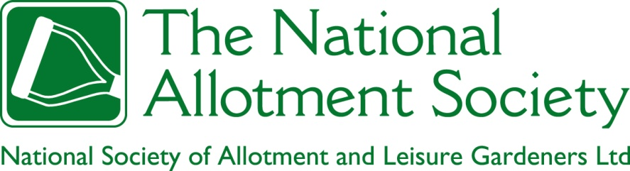

NAS Policy Document 104. Community Access and Security

1. The Society recognises the right of all members of every community (however defined) to cultivate an allotment garden, the enjoyment that persons other than plotholders can obtain from the presence of allotment gardens and gardeners, and the right of plotholders to the peaceful enjoyment of their gardens, free of crime, intimidation or nuisance.

2. The Society recognises that the long-term sustainability of allotments is enhanced by a reputation for openness through organized access, not just to would-be plotholders, but also to other members of the public who may enjoy the visual amenity of well-tended allotment gardens, the casual companionship (and generosity) of allotment gardeners, or participation in gardening through routes other than allotment tenancies (which is also a separate object of policy). Some form of “community access” for plotholders and non-plotholders alike is also required by some funding bodies as a precondition for the award of grants. The Society encourages the periodic and properly authorized opening of allotment sites to the wider public through events such as open days, participation in the Society’s National Allotments Week, the granting of rights to use trading huts to categories of members other than allotment gardeners, and access provisions for former plotholders in good standing who no longer have the physical capacity to maintain a tenancy. The Society will work with funding bodies to ensure that such arrangements are recognised as contributing to requirements for “community access”.

3. At the same time, the Society recognises that the right of plotholders to the peaceful enjoyment of their gardens, free of crime, intimidation and nuisance, does mean that security measures are an essential part of both site infrastructure and everyday practice. The allocation of responsibility for such measures (and for the management of the associated risks) between landlords, associations and individual plotholders should be clear for every allotment site. The Society recognises the importance of hedging, fencing, gates and storage facilities that are appropriate to the risk of trespass with unlawful intent from beyond the boundaries of the allotment site, and which meet current legal requirements. The Society further recognises that the cost of providing and maintaining these facilities should be incorporated into plans for the long-term financial sustainability of sites. The Society will also strive to ensure that allotment associations and individual plotholders enjoy the best possible access to insurance against the risks associated with both public access and criminal behaviour, and will encourage its members to work in effective partnership with the police and other appropriate bodies to address crime and security issues.

